Created by: Mike Bartoli, Ray Santiago, Sam Rhodes

Studio of: Independent Games, Inc.

**Cats vs. Mouse**

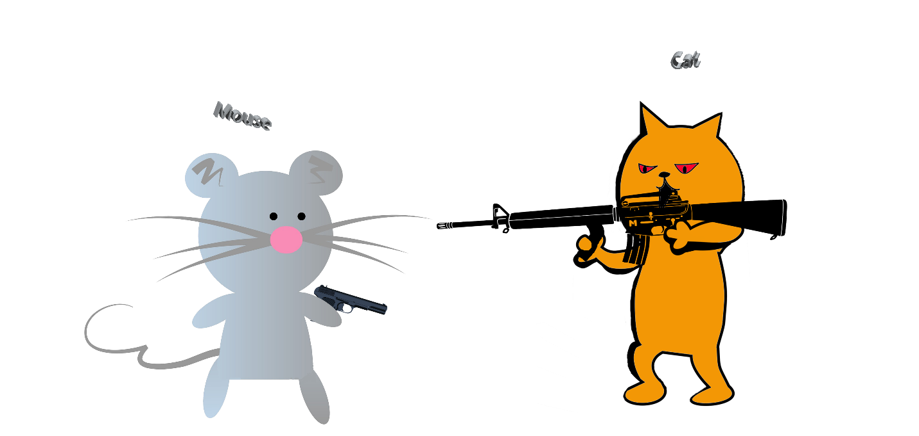

Changes/ Updates

* Added Overview and Audience target to document. 7/4/16
* Added some more things to the audience target area: How many copies we are planning on selling and the target countries we are selling to. 7/4/16

Overview

Cats have taken all of the cheese in the mouse vault and if someone does not get the cheese back, the mouse economy will fall and everyone will starve. The user will experience a fun, exciting, shoot out game for kids who do not usually like shooter games. The game will consist of a number of mini games including the main levels of the game. The game will have a tutorial level where the player will learn the mechanics of the game and how to play through the game. The game is a player vs. game experience where the player goes throughout the level collecting cheese and killing the cats that took the cheese. This is a platform shooter that will consist of 1 tutorial level, 2 mini games and 3 main levels. The game takes place in a mouse village where all mice are created equal and no conflict ever occurs.

Audience

The audience that we are aiming to buy this game are the kids who do not usually like shooter games because this game also has an adventurous feel to it and not just a shooter game. We are hoping to target the age group of 12 years and older. The gender target will be all genders. The platform that we hope to be running on is PC. We chose this platform because we feel like it will run easiest on the PC and it is most compatible with Construct 2. A consumer would purchase our game over some elses because our game has more things to offer like mini games, good quality graphics and a fun story line that the player can really understand. A competitor with us are the creators of the game Maestro: Professional Perfection because their game has the same concept like our game. We plan to sell 5.2 billion copies within the first year of sales. We plan on selling copies in every country in the world except Syria and North Korea.